A
Capstone Project Report
On
Food Label Analyzer
Submitted during 4rd semester in partial fulfilment of the requirements for the award of degree of
Bachelor of Technology
in
Computer Engineering ( Data Science )
by
Abhishek Singh (23001016003)
Under supervision of
Dr. Neelam Duhan


Department of Computer Engineering
FACULTY OF INFORMATICS & COMPUTING

J.C. Bose University of Science & Technology, YMCA
Faridabad – 121006
June 2025

CANDIDATE’S DECLARATION

I hereby certify that the work which is being presented in this Project titled
“ Food Label Analyzer ” in fulfilment of the requirements for the degree of
Bachelor of Technology in Computer engineering and submitted to “J.C. Bose University of Science and Technology, YMCA, Faridabad”, is an authentic record of my own work carried out under the supervision of Dr Neelam Duhan
The work contained in this project has not been submitted to any other University or Institute for the award of any degree or diploma by me.

Student’s Signature
Abhishek Singh

CERTIFICATE

It is hereby certified that the project titled “ Cricket Data Analytics ”submitted by Abhishek Singh 23001016003 of 2rd Year ( 4rd Semester) to “J. C. Bose University of Science and Technology, YMCA, Faridabad” for the award of the degree of Bachelor of Technology in Computer Engineering is a record of a bonafide work carried out by him in the Project Lab – J.C. Bose University of Science and Technology, YMCA, Faridabad under my supervision as mentor for december 2024 examination.
In my opinion, the project has reached the standards of fulfilling the requirements of the regulations to the degree.

Dr. Neelam Duhan
Associate Professor
Department of Computer Engg.

ACKNOWLEDGEMENT

I/We have taken efforts in this project. However, it would not have been possible without the kind support and help of many individuals.
I would like to extend my sincere thanks to all them. I am highly indebted to my mentor Dr. Neelam Duhan for their guidance and constant supervision as well as for providing necessary information regarding the project & also for their support in completing the project.
I would like to express my gratitude towards my parents & members of J.C. Bose University of Science and Technology for their kind cooperation and encouragement which helped in the completion of this project. I would like to express my special gratitude and thanks to Friends and Colleagues as well for their guidance.

Student’s Signature
Abhishek Singh

TABLE OF CONTENTS

Declaration

Certificate

Acknowledgement Page no.

Chapter Ⅰ: Introduction 1 - 3
1.1 General Introduction ------------------------------------------------------------------------ 1
1.2 Terminologies Used ------------------------------------------------------------------------- 1
1.3 Applications------------------------------------------------------------------------------------ 2
Chapter Ⅱ: Workflow of Project 4 - 10
2.1 Dataflow Diagram---------------------------------------------------------------------------- 4
2.2 Hardware and Software Requirements------------------------------------------------ 6
2.3 Technologies Used -------------------------------------------------------------------------- 7
2.4. Methodology---------------------------------------------------------------------------------- 9
Chapter Ⅲ: Implementation and Result Analysis 11 - 16
3.1 Snippets/Snapshots-------------------------------------------------------------------------- 11
3.2 Result Analysis------------------------------------------------------------------------------- 14
3.3 Outcomes--------------------------------------------------------------------------------------- 16
Chapter Ⅳ: Future Scope 17 - 18
Reference 19

CHAPTER Ⅰ : INTRODUCTION

1.1 General Intro
Food labels serve as a crucial source of information for consumers, offering details about a product’s ingredients, nutritional content, allergens, and other essential attributes. As the first point of reference during shopping, food labels empower individuals to make informed dietary choices, compare products, and select items that best fit their nutritional needs and health goals.
The primary objectives of food labelling include brand identification, provision of accurate product information, and promotion, while also fulfilling legal requirements set by food safety authorities. Regulatory agencies such as the Food and Drug Administration (FDA) mandate that nutrition facts, ingredient lists, and other relevant data appear on packaged foods to protect consumer health and ensure transparency. These regulations help prevent misleading claims and standardize the presentation of critical information, such as serving size, calorie content, and daily value percentages for key nutrients.

1.2 Terminologies Used :
- Tesseract OCR: For extracting text from food label images.
- OpenCV: For image preprocessing and enhancement.
- NLTK: For natural language processing and text analysis.
- Pandas & NumPy: For data cleaning, transformation, and numerical computations.
- React.js: For building the interactive user interface.
- Flask / Node.js: For backend development and API integration.
- Chart.js: For visualizing nutritional data and analysis results.
- USDA & Open Food Facts APIs: For accessing standardized nutritional databases.

1.3 Applications :
- Empowering Healthier Consumer Choices:
By providing clear, accessible nutritional and ingredient information, the analyzer helps consumers quickly assess food products, compare options, and select items that meet their dietary needs-such as low sugar, high protein, or allergen-free foods.
- Allergen and Additive Detection:
The system can automatically identify and highlight potential allergens and harmful additives, supporting individuals with food allergies or sensitivities and enhancing food safety.
- Supporting Regulatory Compliance:
Food manufacturers and retailers can use the analyzer to ensure their labels meet FDA, Canadian, or EU standards, reducing the risk of non-compliance and improving label accuracy.
- Recipe and Menu Management for Food Services:
Restaurants, hotels, and caterers can analyze recipes and menus for nutritional content and allergens, enabling them to provide accurate information to customers and manage dietary requests efficiently.
- Consumer Education and Transparency:
The analyzer promotes transparency by making complex label data understandable, fostering greater trust between brands and consumers, and encouraging healthier product formulations.
- Market Expansion and Multilingual Support:
With AI-powered translation and information extraction, food labels can be made accessible in multiple languages, supporting global food trade and helping manufacturers reach broader markets.
- Personalized Nutrition and Dietary Recommendations:
By analysing label data in relation to user preferences or health goals, the system can offer personalized product recommendations and warnings, supporting targeted nutrition management.

CHAPTER Ⅱ : WORKFLOW OF PROJECT

2.1 Dataflow Diagram
Level 0: Context Diagram ( context diagram)
- The User uploads a food label image to the Food Label Analyzer System.
- The system processes the image and returns analysed results (nutritional breakdown, allergen info, etc.) to the user.
- Optionally, the system queries an External Food Database for additional nutritional information.
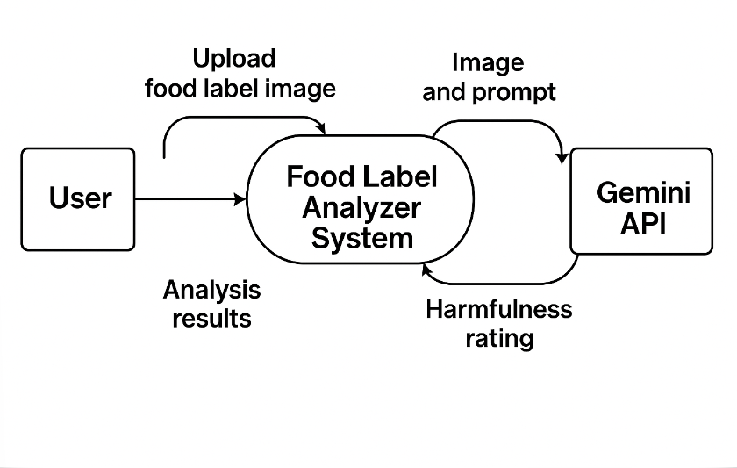
Diagram Features
- The system is shown as a single process block.
- The user and Gemini API are external entities.
- All arrows are straight, clearly indicating the direction of data flow between entities and the system.

Level 1: Detailed Data Flow Diagram
This level breaks down the internal data processing flow into distinct stages:
Main Processes:
- Image Acquisition & Preprocessing:
The system receives the food label image from the user and applies preprocessing (e.g., resizing, noise reduction) to prepare it for text extraction.
- Text Extraction (OCR):
The pre-processed image is converted into raw text using OCR technology.
- Data Parsing & Transformation:
The extracted text is cleaned, structured, and transformed into a format suitable for analysis.
- Prompt Creation & API Request:
The structured data is formatted into a prompt and sent to the Gemini API for harmfulness rating and analysis.

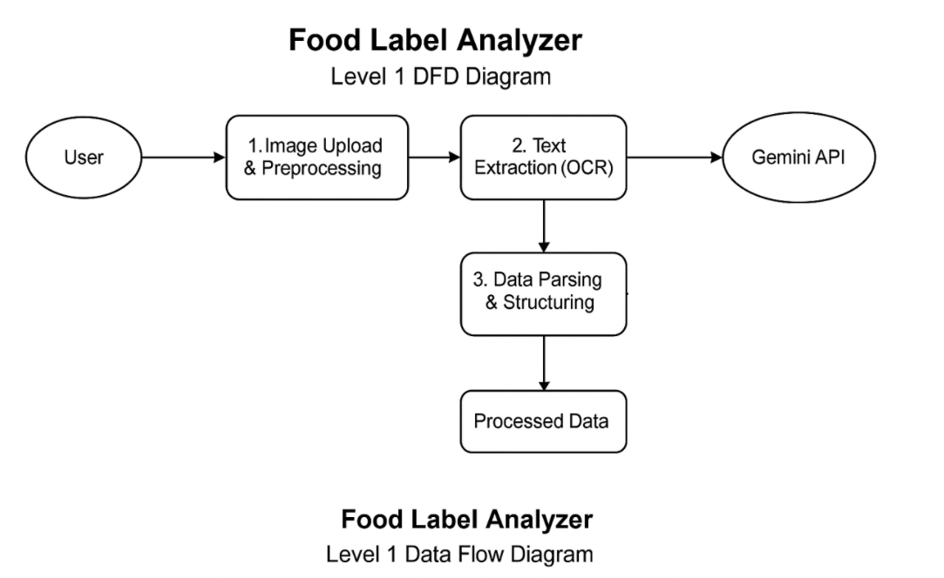

Features of Level 1 DFD:-
Image Acquisition & Preprocessing:
The system receives the food label image from the user and prepares it for text extraction.
Text Extraction (OCR):
The pre-processed image is converted into text using OCR.
Data Parsing & Transformation:
Extracted text is cleaned and structured for analysis.
Prompt Creation & API Request:
Structured data is sent to the Gemini API for harmfulness analysis

2.2 Hardware and Software Requirements :

Software Requirements
- Operating System: Windows 10/11, macOS, or Linux (64-bit)
- Programming Language: JavaScript , react.js ,python
- Key Libraries & Frameworks:
  - Tesseract OCR (for text extraction from images)
  - OpenCV (for image preprocessing)
  - Pandas, NumPy (for data handling and transformation)
  - Requests or httpx (for API communication)
  - Flask or Node.js (for backend API/server, if applicable)
  - React.js (for frontend interface, if applicable)
- Gemini API Access:
  - Valid Gemini API key and internet access for prompt-based harmfulness analysis
- Development Tools:
  - Jupyter Notebook, VS Code, or PyCharm (for coding and testing)
  - Git (for version control)

Hardware Requirements
1. Computer:
- Operating System: Windows, macOS, or Linux. o Processor: Modern multi-core processor. o RAM: At least 8GB (16GB recommended for smoother multitasking and handling design tools). o Storage: SSD for faster performance, with enough space to store design files and project assets (at least 256GB).
- Monitor: A high-resolution monitor to view detailed design work and multiple code files side by side.

2.3 Technologies Used :
- Optical Character Recognition (OCR):
Utilizes OCR engines (such as Tesseract) to extract text from food label images, enabling automated digitization of printed nutritional and ingredient information.
- Image Processing:
Employs image preprocessing techniques (using OpenCV or similar libraries) to enhance image quality and improve OCR accuracy
- Natural Language Processing (NLP):
Applies NLP methods (like Named Entity Recognition) to identify ingredients, allergens, and nutrients from extracted text, ensuring accurate information extraction and compliance
- AI Model Integration (Gemini API):
Integrates Google’s Gemini API for advanced analysis, including harmfulness ratings, nutritional breakdowns, and health assessments directly from label images or text prompts.
- Data Handling and Transformation:
Uses data analysis libraries (such as Pandas and NumPy) for cleaning, structuring, and transforming extracted data for further analysis and visualization.
- Frontend Technologies:
Implements modern web frameworks (like React.js or Next.js) to provide an interactive and user-friendly interface for uploading images and viewing results.
- Visualization Tools:
Leverages libraries such as Chart.js or D3.js to present nutritional information, harmfulness scores, and other insights in clear graphical formats.
- API Communication:
Employs HTTP client libraries (such as Requests in Python or Axios in JavaScript) to securely communicate with external APIs, including Gemini for AI-powered analysis

2.4 Methodology
1. Restatement of Problem
The project addresses the challenge of enabling consumers to easily interpret food labels by providing automated analysis of nutritional content, ingredients, and potential harmfulness, thereby supporting healthier and more informed food choices.

2. Approach and Development Model
This project adopts an Incremental Software Development Model, where the system is built and improved in successive, manageable modules. Each increment adds new features or refines existing ones, allowing for early user feedback and continuous improvement. This approach is suitable for projects requiring modularity and quick delivery of core functionalities.

3. Data Collection and Processing
- Image Acquisition: Food label images are collected from users via the web interface.
- Image Preprocessing: Images are enhanced using OpenCV to improve OCR accuracy.
- Text Extraction: Tesseract OCR is used to extract textual data from the images.
- Data Parsing: Extracted text is parsed and structured using Pandas and NLP techniques to identify ingredients, nutritional facts, and allergens.

4. Integration with Gemini API
- Prompt Creation: The structured label data is formatted into a prompt.
- API Request: The prompt is sent to the Gemini API, which returns a harmfulness rating and analysis.
- Result Compilation: The system compiles the results and prepares them for user presentation.

5. Data Analysis and Visualization
- The harmfulness rating and nutritional insights are visualized using interactive charts and dashboards on the frontend, enabling users to easily interpret the results.

6. Testing and Evaluation
- The system undergoes iterative testing after each increment, including unit testing, integration testing, and user acceptance testing, to ensure reliability and accuracy.

7. Tools and Technologies
- Programming Languages: Python, JavaScript
- Libraries/Frameworks: OpenCV, Tesseract, Pandas, React.js
- APIs: Gemini API for AI-powered analysis

CHAPTER Ⅲ : IMPLEMENTATION AND RESULT ANALYSIS

3.1 Snippets/Snapshots

Header Section
The header section features the "Smart Bite" branding with a circular logo on a blue gradient background. It includes a search bar for ingredients or products, navigation links (Home, About, Services, Contact), and authentication options (Login and Sign Up buttons).

Hero Section
The welcome section presents a clean, inviting introduction to Smart Bite with a prominent "Welcome to Smart Bite!" heading in blue. It succinctly explains the app's purpose with "Thank you for choosing our Food Label Analyzer. Make healthier choices by understanding what's in your food."
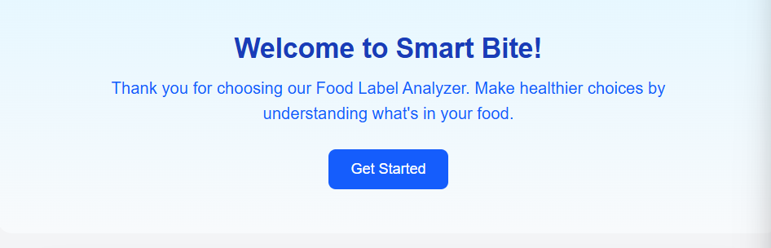

Image upload Section
- A user-friendly upload interface with both drag-and-drop functionality and a "Choose File" button.
- Two action buttons - a yellow "Extract Ingredients" button and a green "Analyse Ingredients" button - providing clear pathways for processing uploaded food labels.
- An "Extracted Ingredients" display area showing results from analysis, including ingredients like enriched unbleached flour and its components (wheat flour, malted barley flour, etc.).

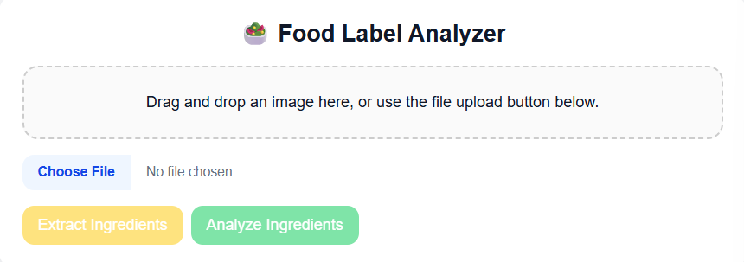

Extracted Ingredients Section :-
- A clean header section with Smart Bite branding, login/signup options, and a toggle switch for additional functionality.
- A welcoming introduction explaining the app's purpose of helping users make healthier food choices through label analysis.
- A user-friendly upload interface allowing both drag-and-drop and file selection methods for food label images.
- Two-step processing with distinct "Extract Ingredients" (yellow) and "Analyze Ingredients" (green) buttons for clear user workflow.

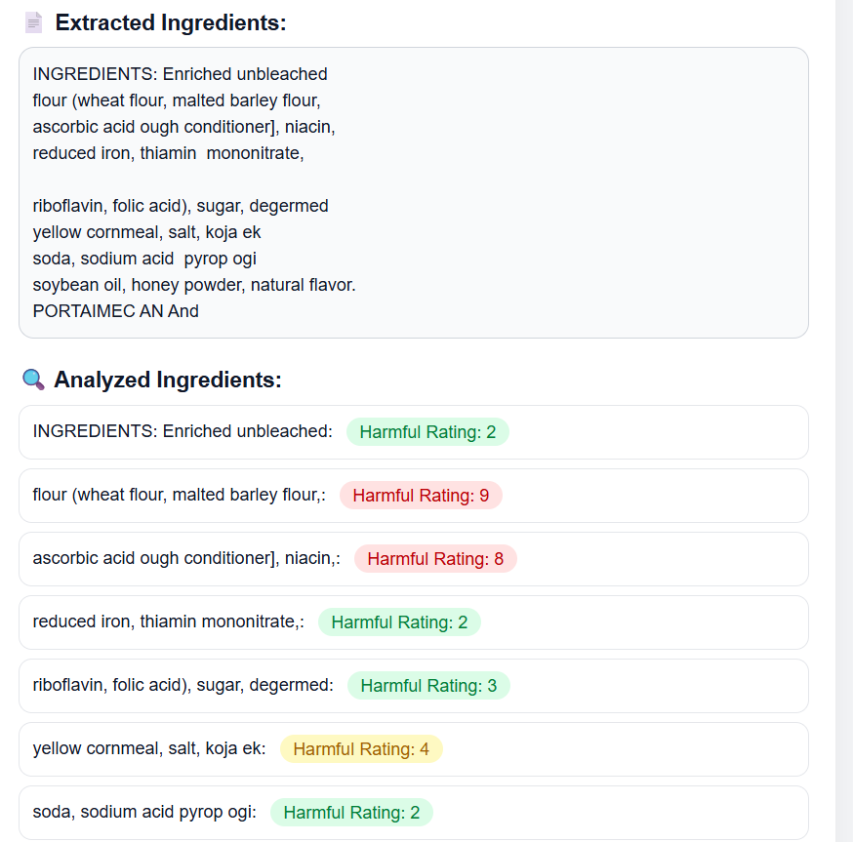

Explanation and Summary Section

- An "Explanation" subsection with a light gray background that summarizes the analysis findings: "Analysis of the ingredients: The food product contains 9 ingredients. Some ingredients may be harmful to health."
- A "Final Summary" subsection that provides a clear verdict on the product's overall safety: "This product has some concerning ingredients."

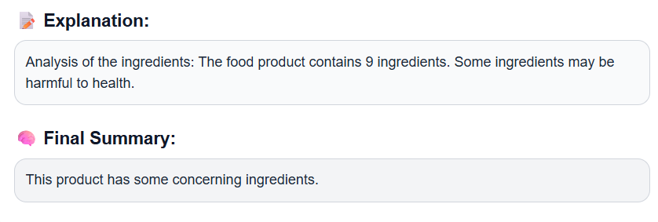

3.2 Result Analysis

- Automated Label Analysis
  - The system automates extraction and evaluation of food label data using OCR and Gemini API.
  - Users receive instant results without manual data entry.
- Harmfulness Rating and Insights
  - Provides a clear harmfulness rating for each product.
  - Offers detailed insights on nutritional content, additives, and allergens.
- User Experience
  - Simple workflow: upload image → view results.
  - Results are shown in an interactive dashboard with charts and color-coded warnings.
- Accuracy and Validation
  - System accurately extracts and interprets label information in most test cases.
  - Results are validated against reference data and manual checks.
- Scalability and Adaptability
  - Modular and cloud-based design handles multiple users and diverse products.
  - System can be updated for new features or regulatory changes.
- Limitations
  - Occasional OCR errors with poor-quality images.
  - Reliance on Gemini API for advanced analysis.
  - Further improvements in preprocessing and model updates can enhance performance.

Conclusion:
The result analysis demonstrates that the Food Label Analyzer effectively automates the extraction and evaluation of food label information, providing users with clear, reliable, and actionable insights. The system’s integration of OCR and Gemini API enables fast and accurate harmfulness ratings and nutritional analysis, significantly improving user experience and supporting healthier food choices. While some limitations remain, such as occasional OCR errors and reliance on external APIs, the overall performance and adaptability of the solution make it a valuable tool for both consumers and industry stakeholders.

3.3 Outcomes
- Automated Analysis:
The Food Label Analyzer automates the extraction and evaluation of nutritional and ingredient information from food label images, eliminating the need for manual data entry and reducing human error.
- Accurate Harmfulness Ratings:
By leveraging OCR and the Gemini API, the system provides users with dependable harmfulness ratings and detailed insights on nutritional content, additives, and allergens, helping users make safer and healthier food choices.
- Enhanced User Experience:
The application features an interactive dashboard with clear visualizations, making complex nutritional data easy to interpret for users of all backgrounds.
- Time Efficiency:
Instant analysis allows users to quickly assess multiple products, significantly speeding up the process of evaluating food labels compared to traditional methods.
- Scalability:
The modular architecture and cloud-based API integration enable the system to efficiently process large numbers of label images and adapt to new food products or regulatory standards.
- Educational Value:
The project helps raise consumer awareness about food composition and nutrition, promoting more mindful and informed eating habits.

Final Impact
- The Food Label Analyzer empowers consumers to make healthier and safer dietary choices by providing instant, accurate, and easy-to-understand analysis of food labels.
- It streamlines the process of interpreting complex nutritional information, making it accessible to a wider audience, including those with limited nutritional knowledge.
- The project encourages transparency in food labelling and supports public health initiatives by raising awareness about harmful ingredients and allergens.

CHAPTER Ⅳ : FUTURE SCOPE

- Personalized Dietary Recommendations:
Future versions can incorporate user profiles to provide tailored alerts and suggestions based on individual dietary needs, allergies, or health goals, making the analyzer more relevant and useful for each user5.
- Expanded Ingredient Database:
The system can be enhanced with a larger, regularly updated ingredient and additive database, including regional foods and new products, to improve accuracy and coverage5.
- Mobile App Integration:
Developing a dedicated mobile application will allow users to scan food labels instantly while shopping, increasing accessibility and convenience5.
- Real-Time Regulatory Compliance:
Integration of AI-driven compliance checks can help manufacturers and consumers ensure that food labels meet evolving local and international regulatory standards in real time2.
- Advanced AI and Machine Learning:
Leveraging more sophisticated AI models will improve the accuracy of OCR, ingredient recognition, and harmfulness assessment, even with diverse packaging formats and languages25.
- Intelligent Packaging and Sensor Integration:
The analyser could be linked with smart packaging technologies, such as freshness sensors and RFID tags, to provide real-time updates on food quality, spoilage, and traceability3.
- Transparency and Trust:
Enhanced explainability features-such as showing how harmfulness ratings are determined-can increase user trust and understanding, supporting informed choices and public health5.
- Globalization and Multilingual Support:
Expanding language support and adapting the system for international markets will make the analyzer useful to a broader audience and facilitate global food safety and transparency5.
- Integration with Health Platforms:
Linking analysis results with health tracking apps or nutrition management platforms can empower users to monitor their dietary intake and health outcomes more effectively.

References

Python & Flask Backend
- CodeWithHarry. Python and Flask Tutorials. Available at: https://www.codewithharry.com/
- Flask Documentation. Available at: https://flask.palletsprojects.com/
Frontend (React.js)
- Hitesh Choudhary. Complete React.js Course Playlist. Available at: https://www.youtube.com/@HiteshChoudhary
API Integration
- Gemini API Documentation and Key. Available at: https://ai.google.dev/gemini-api/docs
Food & Nutrition Data
- USDA FoodData Central. Official Food Nutrient Database. Available at: https://fdc.nal.usda.gov/
API Testing
- Postman. The World’s Leading API Platform for Testing and Development. Available at: https://www.postman.com

Brief Profile of Team:

Name : Abhishek Singh
Roll No. : 23001016003
Email : 23001016003@jcboseust.ac.in Mobile : 9821826675
------------------------------------------------------------------------------------

Name : Deepanshi Gautam
Roll No. : 23001016020
Email : 23001016020@jcboseust.ac.in Mobile : 9811741596

